**RESUME**

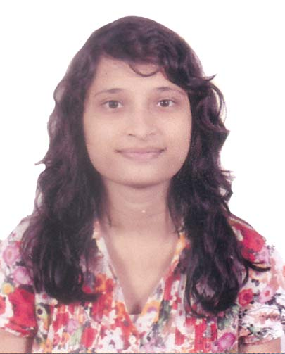

BIDROHI ANANYA BISWAS

B. Tech (Completed)

Department of Computer Science Engineering

IEM, KOLKATA, WB, INDIA.

E-mail : ananyatanaya1996@gmail.com

Mobile : 01879506572

**Career Objective**: To pursue a challenging career and be part of a progressive organization that gives scope to enhance my knowledge, skills and to reach the pinnacle in the computing and technical field with sheer determination, dedication and hard work.

**Papers:**

* Suparna Saha Biswas; Sourav Saha; Prachatos Mitra; Retabrata Chatterjee; Ronit Ray; Paramartha Saha; Rajarshi Basu; Saurav Patra; Pritam Paul; Bidrohi Ananya Biswas, “**Drunken driving detection and prevention models using Internet of Things**”, *IEEE Xplore Digital Library, 2016.*

**Projects:**

* **Project Title: *Detection of Collapsing Probability of Structures using IoT*,** August, 2017 - May, 2018.

**Supervisor:** Ee-Kian Wong, Department of Computer Science Engineering, Institute of Engineering & Management, India.

* **Project Title: *Environmental Pollution Monitoring System using IoT*,** January - May, 2018.

**Supervisor:** Ee-Kian Wong, Department of Computer Science, Institute of Engineering & Management, India.

* **Project Title: *Android Music Player*,** July-August, 2017.

**Supervisor:** Mohd Daneyal Hasan, Lead Trainer at RCPL, India.

* **Project Title: *Flight Reservation System Application*,** August-December, 2016

**Supervisor:** Ee–Kian Wong, Department of Computer Science Engineering, Institute of Engineering & Management, India.

**Academic Profile:**

|  |  |  |  |
| --- | --- | --- | --- |
| **Examination Passed** | **University/Board** | **Year** | **Grade Obtained** |
| S.S.C. | Chittagong Board | 2012 | 4.69 out of 5.00 |
| H.S.C. | Chittagong Board | 2014 | 4.10 out of 5.00 |
| B. Tech  (Computer Science and Engineering) | MAKAUT (previously known as WBUT) | 2018 | CGPA  7.12 out of  10 (Average of 8 Semesters) |

**Technical Skills:**

Programming languages: C, Data Structure, DBMS, JAVA

Operating System : Windows, Android

**Academic Participation:**

* Participated in a 1-day Industrial Visit in Cognizant Technology Solutions(CTS), India, March 2017. Also participated in a seminar on “Current Industry and Research Scopes in India”.
* Completed 6-weeks Summer Training on “Core Java with Android” conducted by RCPL and certification by Oracle University, July-August, 2017
* Participated in a 1-day International Science & Technology Congress (IEMCONGRESS), India, August 2014.

Experience:

Telemarketing Executive

Trust Global Communication

Sanmar RL Park view ,Khulshi, Chittagong July’18-September’18

SOFTWARE DEVELOPER

ICT Research & Engineering

Bodoray Mohol(Ground Floor),G.E.C, CHITTAGONG February’19-Present

**Field of interest**: Algorithms, Android Application Development, Object Oriented Technology, Mathematics, Internet of Things.

**Extra Co-Curricular Activities:**

1. Bangla Academy Prize on “Folk Dance” from Notun Kuri.
2. Learnt “Bharatanatyam” Dance.

**Personal Profile:**

|  |  |
| --- | --- |
| Name: | BIDROHI ANANYA BISWAS |
| Gender: | Female |
| Date of birth: | 20-03-1996 |
| Marital status: | Unmarried |
| Father’s Name: | Ashim Biswas |

Linguistic Ability: English, Bangla,Hindi

Present Address: 50, Jamalkhan, Kotwali, Chittagong.

Personal Strength: Leadership Skill, Managerial Skill.

**Declaration:** I hereby declare that all the details mentioned above are true to the best of my knowledge and belief.